Steps in deploying ML model using AWS EC2 instance

Part I

1. Create AWS Free Tier account



[AWS Free Tier](https://aws.amazon.com/free/?trk=78b916d7-7c94-4cab-98d9-0ce5e648dd5f&sc_channel=ps&ef_id=CjwKCAjw69moBhBgEiwAUFCx2MrzCD-Qs99tU9X1dPH4pVxP1TsONHeqoNh6Yzgffe1Dn7bk9CKrxRoC_BAQAvD_BwE:G:s&s_kwcid=AL!4422!3!432339156165!e!!g!!aws%20free%20tier%20account!9572385111!102212379047&all-free-tier.sort-by=item.additionalFields.SortRank&all-free-tier.sort-order=asc&awsf.Free%20Tier%20Types=*all&awsf.Free%20Tier%20Categories=*all)

1. Go to the search bar, type EC2, and click on EC2

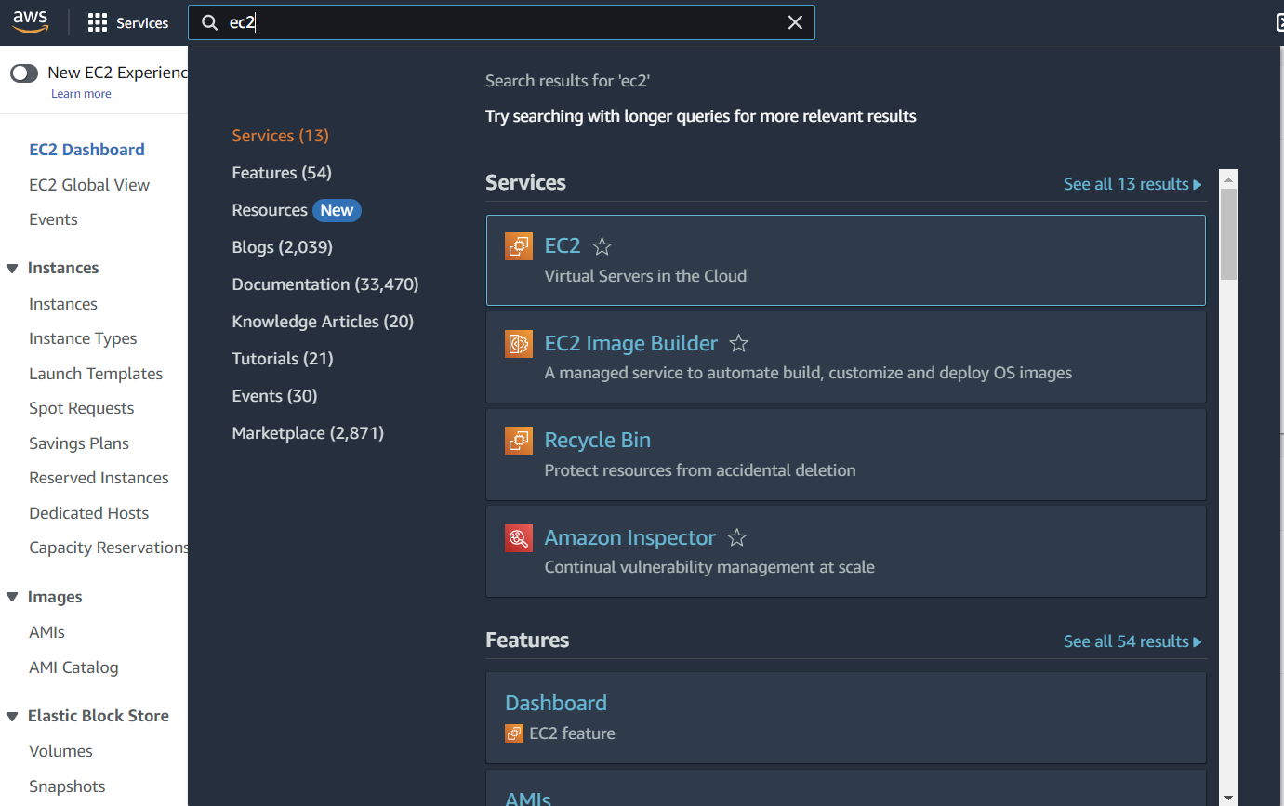

1. Click on Launch instance

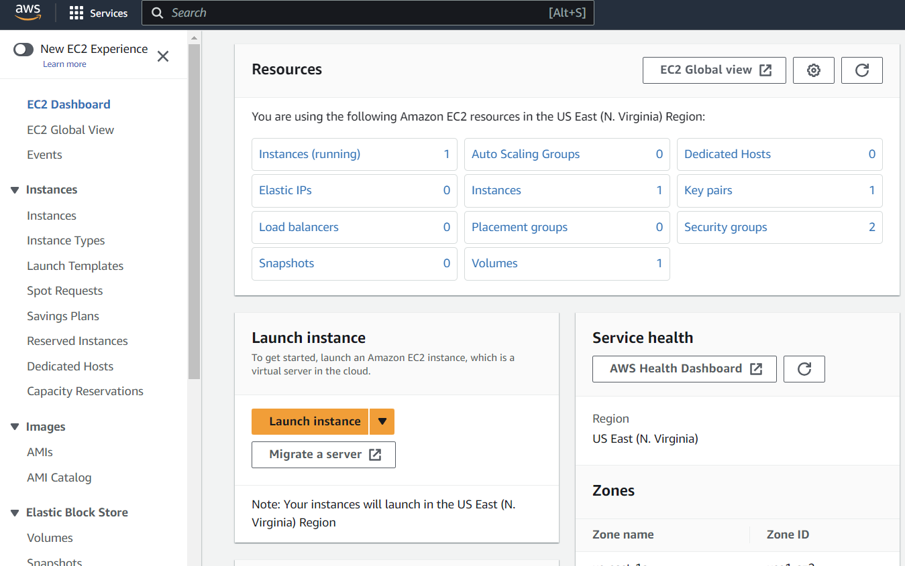

1. Give name for your app

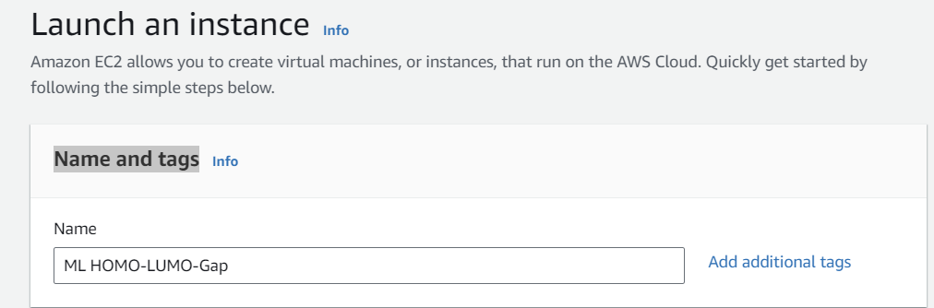

1. Select the operating system

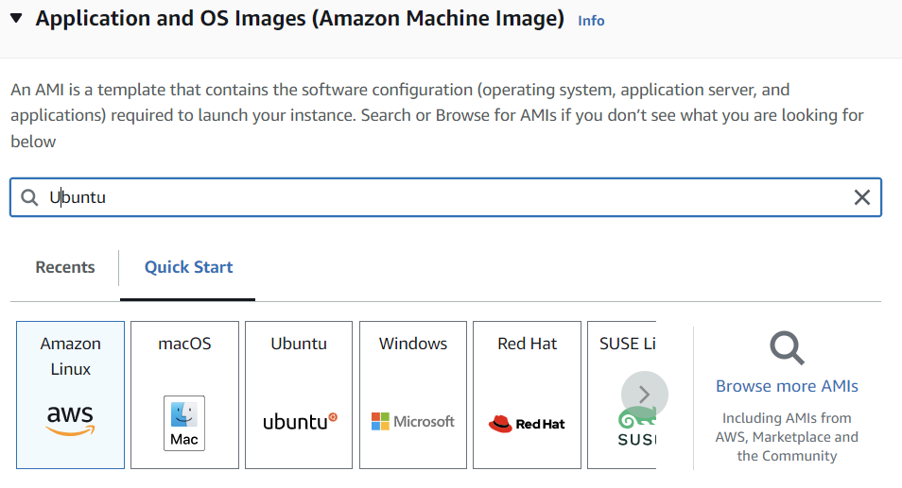

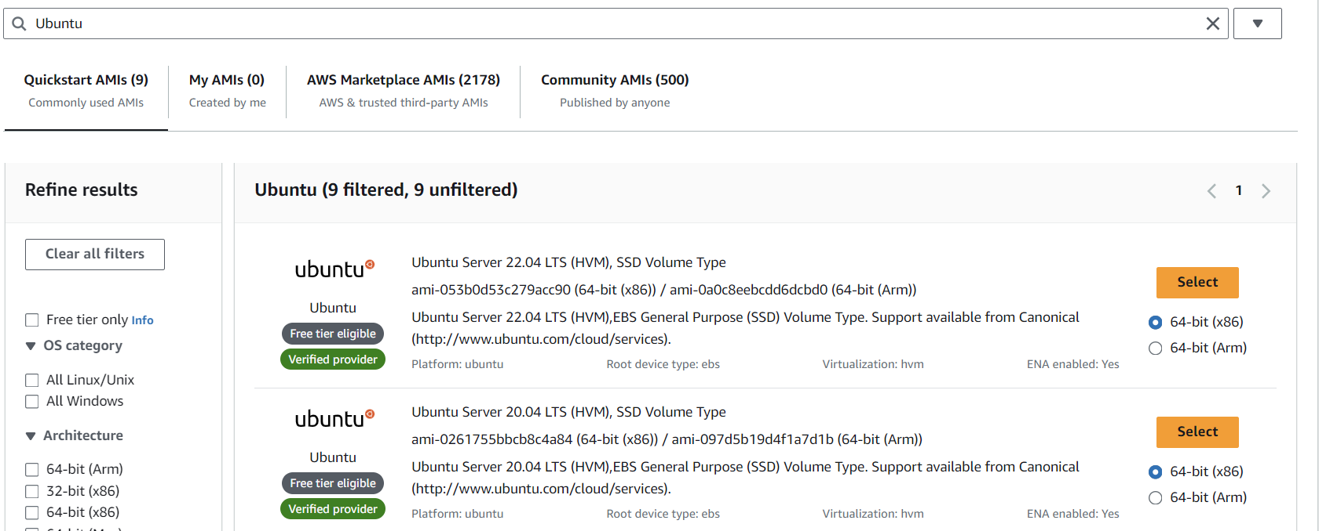

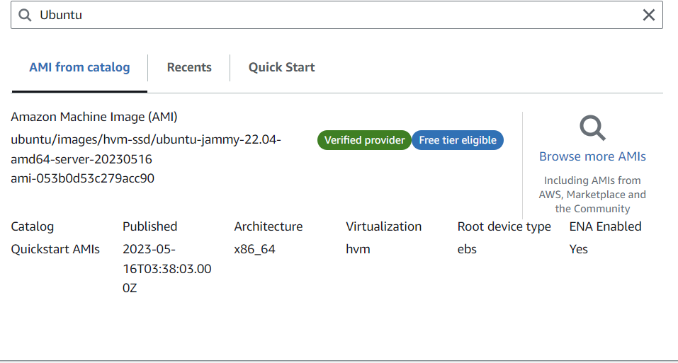

1. Create key-pair and save .pem file in your computer.

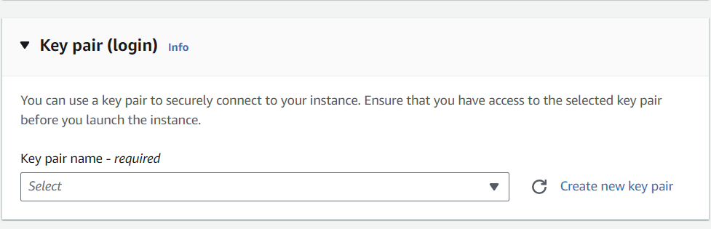

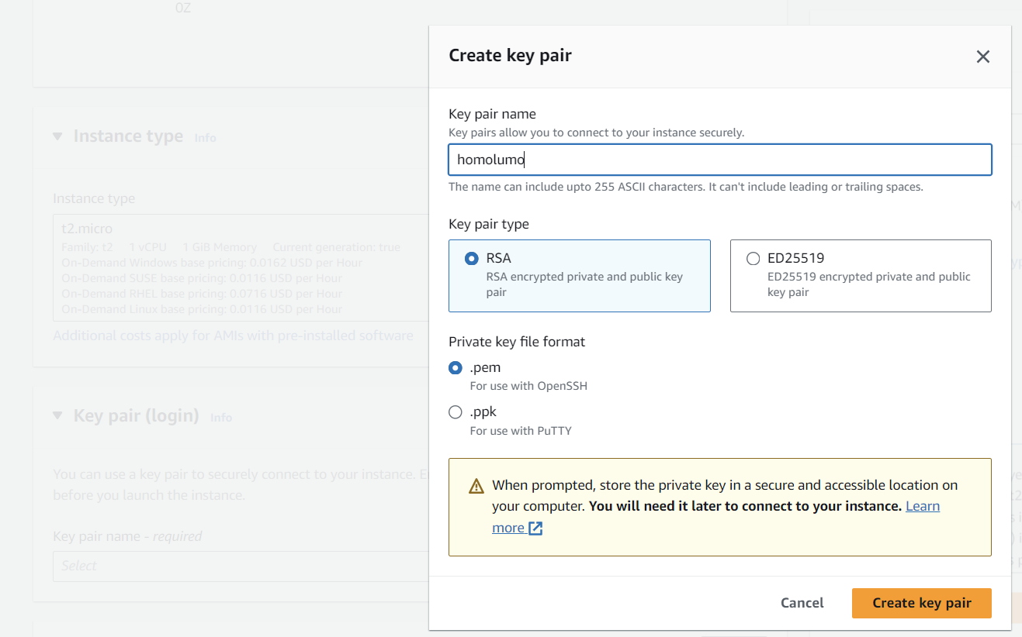

1. Use the remaining default values and launch the instance.

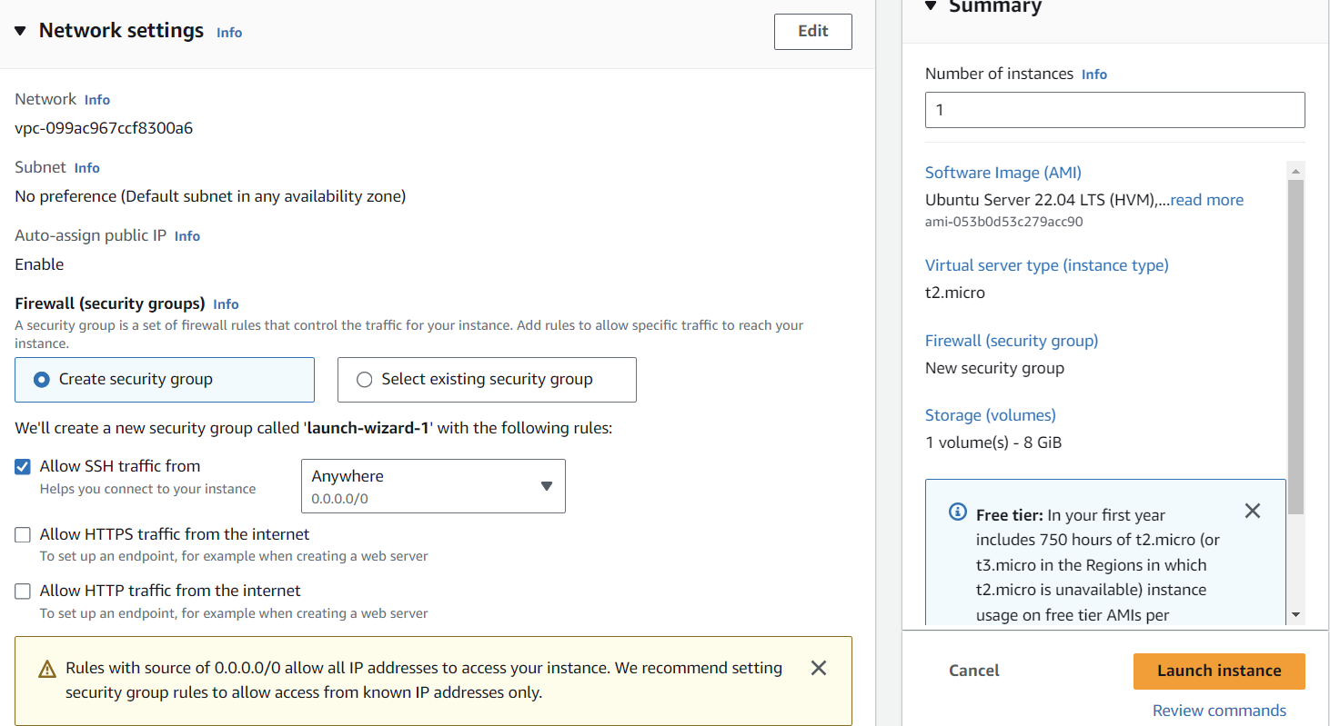

Part II

1. Install three software packages (Putty, PuttyGen and WinSCP)

<https://www.putty.org/>

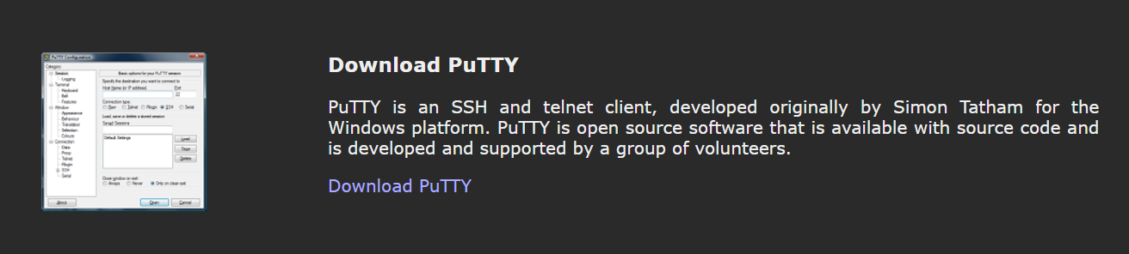

[https://www.puttygen.com/download-putty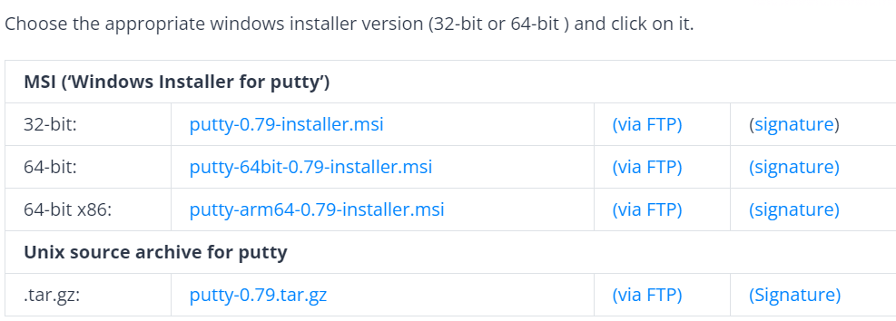](https://www.puttygen.com/download-putty)

<https://winscp.net/eng/download.php>

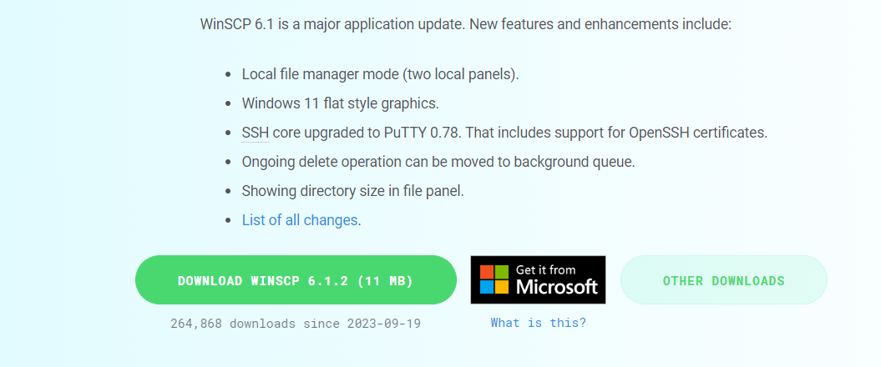

1. Generate the private key using PuTTYgen

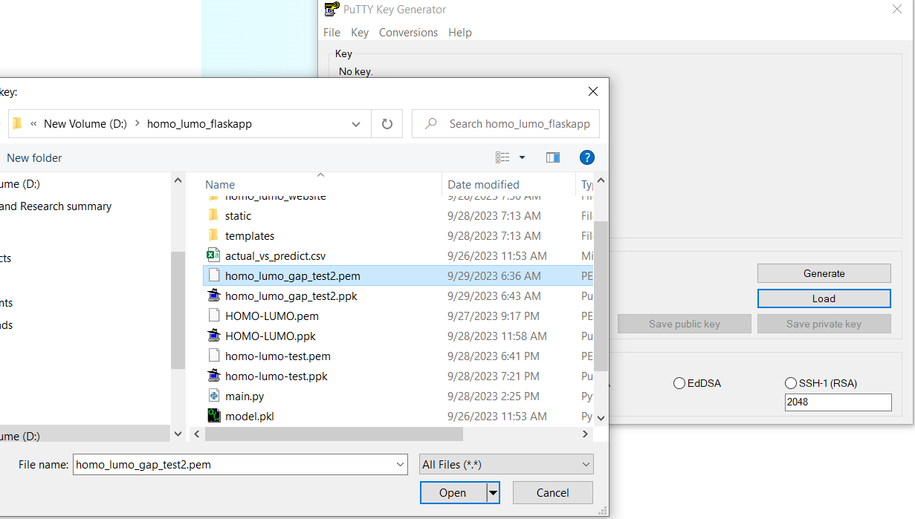

1. Use WinSCP to move your files by drag and drop to your EC2 instance storage

* First connect to EC2 instance using its public IP address or Public IPv4 DNS and using the private key generated using PuTTYgen.

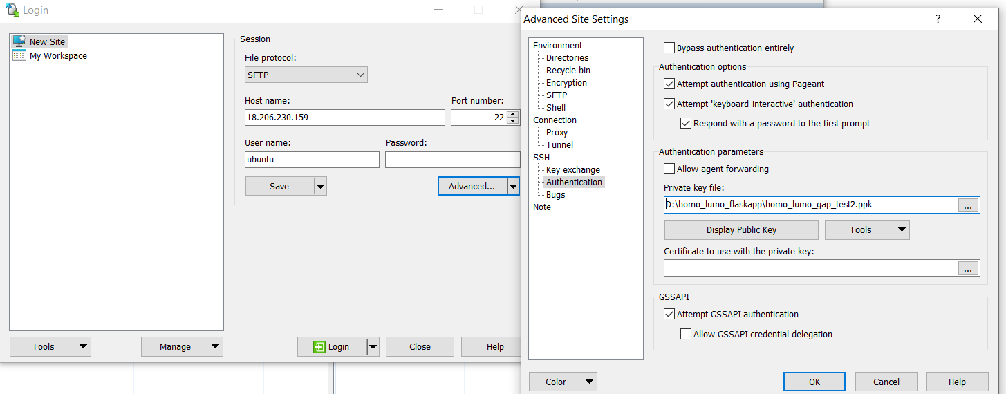

* Drag and drop files needed to run your app from your local folder to EC2 instance storage.

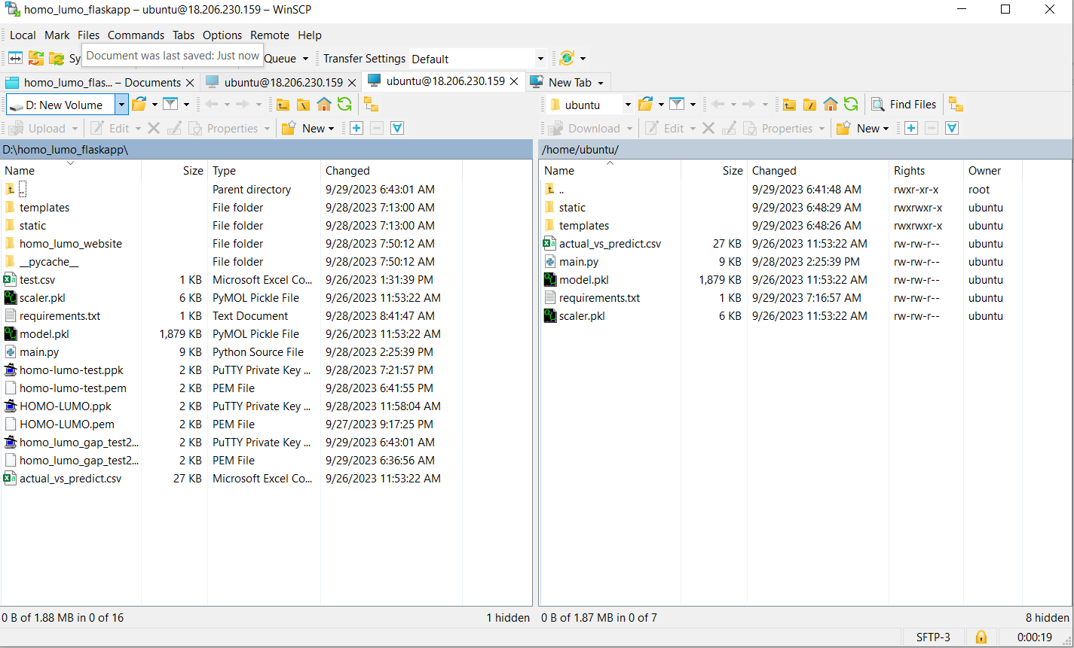

I deployed a ML web app for HOMO-LUMO gap prediction using AWS CE2 instance

